Years 3-4

Programming and algorithms and KLA examples

|  |  |  |  |  |
| --- | --- | --- | --- | --- |
| **Specific DT focus** | **Subject area** | **Short focus** | **Summary** | **Title** |
| Pathways | English | Clear, precise communication | In pairs, explore giving and following a sequence of steps and decisions to build a LEGO® toy. | Take a LEGO® building challenge |
| Decision making (branching) | Create a storyboard to plan a story where the reader is provided with a number of decisions that lead to alternative endings. | Plan a 'choose your own adventure' story |
| Mathematics | Decision making (branching) | Create a flowchart to represent a sequence of (branching) steps and decisions needed to solve a mathematical problem. | Have fun with flowcharts |
| Choices | English | Implementing a digital solution using visual programming | Based on your storyboard for a 'choose your own adventure' story, use a visual programming language to implement a digital solution. |  |
| Create a multimodal game board where the player is provided with a number of decisions. Using Scratch and Makey Makey, add multimodal elements to the story. These are activated using an Ozobot. | Create a game board that uses an Ozobot |
| Sequencing instructions to complete a task | Plan and create a computer program to demonstrate grammar or spelling rules, eg changing nouns from singular to plural; adding ‘ing’. |  |
| HAAS: History | Implementing a digital solution, using visual programming | Design and create a simple game/quiz to demonstrate convict crimes and punishments. | Design a quiz –Convicts: crime and punishment |
| HAAS: Geography | Implementing a digital solution, using visual programming | Create a computer program for learning a traditional Aboriginal or Torres Strait Islander language. | Create a language -learning program |
| Science | Implementing a digital solution, using visual programming | Design and create a simple quiz to explore the difference between living and non-living things. |  |
| Mathematics | Implementing a digital solution, using visual programming | Modify an existing program or create a program to design a geometric shape or design using Pencil code or similar application. |  |
| Programming a robotic device to follow a path | Create a maze or route for a programmable robot to travel. Estimate and calculate angles and distances. |  |
| Working together | HPE | Collaboration | Collaborate to decide the rules for a new game. Use a flowchart to explain the consequences of unfair play. |  |

**Title**: Plan a ‘choose your own adventure' story

***SUB HEADING***: Decision making (branching)

**Summary Text:** Students create a storyboard to plan a ‘choose your own adventure' story, where the reader is provided with a number of decisions that lead to alternative endings.

**Year Level**: 3–4

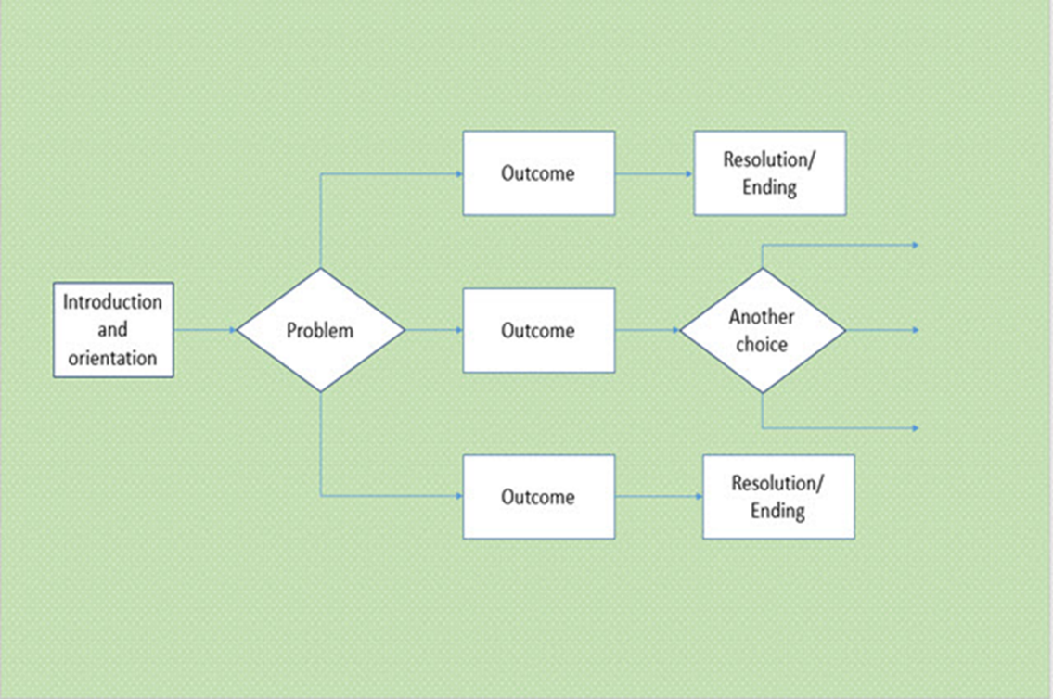

Martin original image

# Suggested steps

1. Read a ‘choose your own adventure' story to the class and model the construction of a storyboard to graphically portray the choices the reader encounters and the subsequent outcome of each choice. Explain that the concept of a choose your own adventure story is to allow the readers to choose different pathways leading to alternative events within the plot.

 To allow for multiple means of representation, you could also show a flowchart (like the one above) and have students come up with examples of a problem that could have three solutions.

Also, instead of a story, you could also model a familiar sequence like ‘How to enter the classroom’ or ‘How to make a pizza’ so that the task is a bit more familiar. Note: you may want to do the ‘choose your own adventure’ story later as it allows for multiple endings.

1. Students explore the concept of decisions (branching) by planning and creating their own choose your own adventure story.

 You may wish to keep planning and decision making to simple Yes-No branching at the start, then add complexity as appropriate.

1. Students use a storyboard to graphically display the plot, including all choices offered and alternative endings.

To allow for multiple means of expression, students could do this activity on paper (A3 suggested), with physical blocks (rectangles and diamonds/squares), or using a computer program such as Microsoft Word or PowerPoint.

1. Students use the Hyperlink function within PowerPoint to create the interactive story. Branching options can be provided via buttons or symbols to support the reader to navigate their way through the plot.

Perhaps have students work in pairs and/or share their stories as a form of debugging.

# Discussion

* Invite students to share their interactive stories with their peers and discuss the alternative endings or variations to endings.
* List some of the choices the students have provided the readers as alternative pathways within the plot.
* Consider how some choices lead to a chain of events that are riskier than others?
* Explain that a choose your own adventure story can be likened to the concept of ‘branching’ or decision making where we can change our actions based on the value of data.

**Extension Task:** You can have students include programming language in their visual flowchart (e.g. “if yes then”, “else if”, and “while”).

* Ask students to consider the information they had to provide the reader to help them make their decision. Was there enough information provided to help them decide which path to take? Was it confusing at any point? Centre the discussion on data and ask student to suggest what data was needed to help readers make their decisions.

# Why is this relevant?

Decisions are an important concept of computational thinking. They allow actions to be changed based on the value of data. Algorithms are the step-by-step procedures required for solving a problem. A storyboard depicting a choice of events within a plot is a fun way of visualising algorithms and can be an effective way to teach the concept of ‘branching’. Branching involves making a decision between one of two or more actions depending on sets of conditions and the data provided.

This activity can be used to strengthen students understanding of computer programming as a series of instructions that can change depending on different user inputs or conditions. The focus is on how computers follow instructional pathways.

# Assessment

Evaluate students’ understanding using a simple checklist. For example:

* The storyboard represents a sequence of events that follow a well-defined plot.
* The storyboard provides the reader with a choice of options leading to alternative endings.
* The interactive story is correctly hyperlinked directing the reader to the correct event within the plot.
* Navigation buttons have been used effectively

# Australian Curriculum alignment

## Technologies – Digital Technologies

Implement simple digital solutions as visual programs with algorithms involving branching (decisions) and user input [(ACTDIP011)](http://www.australiancurriculum.edu.au/curriculum/contentdescription/ACTDIP011)

Explain how student solutions and existing information systems meet common personal, school or community needs [(ACTDIP012)](http://www.australiancurriculum.edu.au/curriculum/contentdescription/ACTDIP012)

## English

### Creating literature

Create imaginative texts based on characters, settings and events from students’ own and other cultures using visual features, for example perspective, distance and angle [(ACELT1601](http://www.australiancurriculum.edu.au/curriculum/contentdescription/ACELT1601))

### Creating texts

Plan, draft and publish imaginative, informative and persuasive texts demonstrating increasing control over text structures and language features and selecting print, and multimodal elements appropriate to the audience and purpose [(ACELY1682)](http://www.australiancurriculum.edu.au/curriculum/contentdescription/ACELY1682)

Use software including [word](http://www.australiancurriculum.edu.au/glossary/popup?a=E&t=word) processing programs with growing speed and efficiency to construct and edit texts featuring visual, print and audio elements [(ACELY1685)](http://www.australiancurriculum.edu.au/curriculum/contentdescription/ACELY1685)

Create literary texts by developing storylines, characters and settings [(ACELT1794)](http://www.australiancurriculum.edu.au/curriculum/contentdescription/ACELT1794)

## ICT Capability

**Level 3**

Typically by the end of Year 4, students:

**Select and use hardware and software**

* identify and independently operate a range of devices, software, functions and commands, taking into consideration ergonomics when operating appropriate ICT systems, and seek solutions when encountering a problem

**Collaborate, share and exchange**

* use appropriate ICT tools safely to share and exchange information with appropriate known audiences